TEEN CENTERS
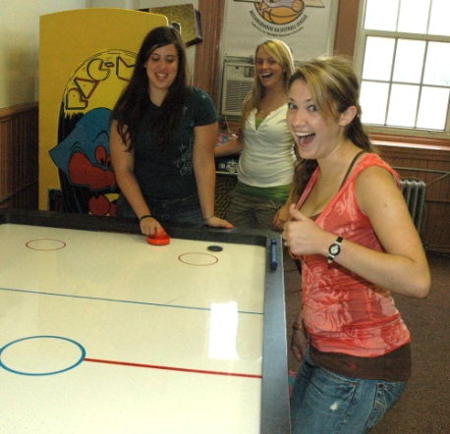
The Teen Centers provide a wide range of recreation and social programs for youth, ages 13 to 18. They offer educational and cultural programs, youth development training, mentoring workshops and job readiness courses, in addition to the sports and fitness programs offered at other recreation facilities. Outreach services are also provided to recruit and engage youth in the community who may be at risk.
- Drop-in Center with pool tables, TVs, computers and video games
- Educational programs, including GED classes and mentoring
- Cultural activities, including photography, ceramics and jewelry-making
- Movie nights and social events
- Sports, including basketball, volleyball, soccer and co-ed leagues
- Special Events!

For more information visit http://www.phila.gov/recreation/teens/Teen_Centers.html or contact the Teen Center Supervisor

Disston Recreation Center  4423 Longshore Avenue (19135)  215-685-8750  Supervisor: Andy McLaughlin  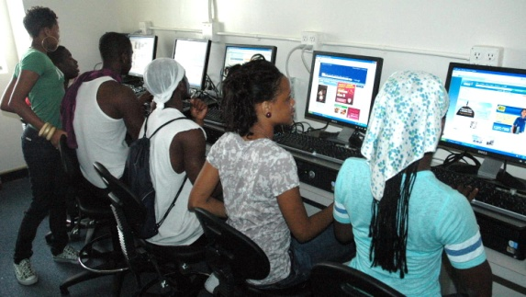  Dorothy Emanuel Recreation Center  Pickering and Gowen (19150)  215-685-9253  Supervisor: Azahara Robinson  Feltonville Recreation Center  Ella and Wyoming (19120)  215-685-9150  Supervisor: Ed Henninger  M.L. King Recreation Center  22nd & Cecil B. Moore (19121)  215-685-2733  Supervisor: Wanda Darden  Kingsessing Recreation Center  48th Street and Kingsessing Ave. (19143)  215-685-2695  Supervisor: Les Quill  Lawncrest Recreation Center  Rising Sun & Comly (19111)  215-685-0597  Supervisor: Jim Ritvalsky  McVeigh Recreation Center  D St. & Ontario Ave. (19124)  215-685-9897 or 9898  Supervisor: Connie Summerow | Murphy Recreation Center  300 Shunk Street (19148)  215-685-985-1893  Supervisor: George Sumner  Francis Myers Recreation Center  58th Street & Kingsessing Ave. (19143)  215-685-2698  Supervisor: Daryl Nelson  Rivera Recreation Center  Fifth St. & Allegheny Ave. (19140)  215-685-9887  Supervisor: Brian Andrews  Shepard Recreation Center  57th Street & Haverford Avenue (19131)  215-685-1992  Supervisor: Steve Hoppel  Simons Recreation Center  Walnut Lane & Woolston Ave. (19138)  215-685-2888  Supervisor: Donnell Martin  Vare Recreation Center  2600 Morris Street (19145)  215-685-1876  Supervisor: Bill Powell

